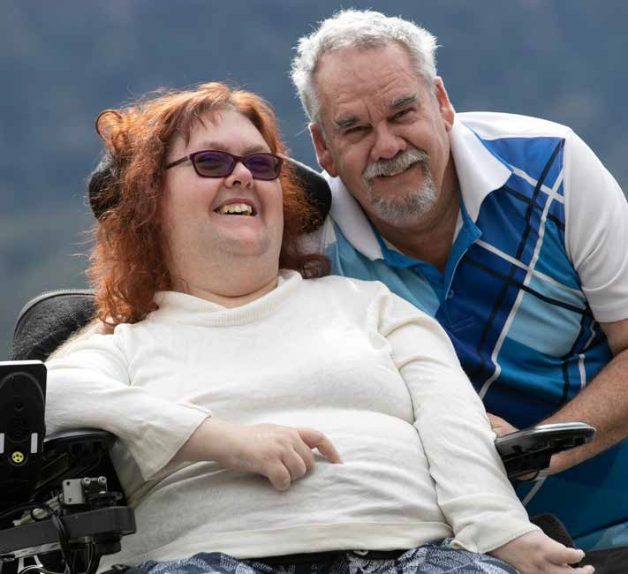
Figure 1: Image Participant Jen and her dad Russell smiling at the camera
ANNUAL
2022/23
REPORT

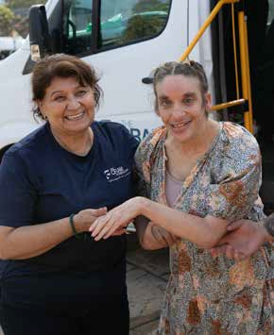
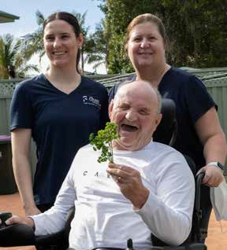
TABLE OF CONTENTS
Figure 2: Image Erica and Participant Rachel smiling for the camera
Figure 3: Image Participant Barry and staff enjoying his garden
ACKNOWLEDGEMENT OF COUNTRY
The Cram Foundation acknowledges the traditional owners of the land on which we work and live. We pay our respect to Elders past, present and future. We believe the richness of the stories of our First Nations people - the oldest known civilisation on earth, their connection to country and their strength and resilience in truth telling, enhance Australian culture now and into the future.
ACKNOWLEDGE SUPPORTERS AND DONORS
Cram wish to acknowledge the support and collaboration of our many partners, colleagues, volunteers, suppliers and fellow providers for working with us to achieve the best outcomes for our Participants. We thank the below organisations for the many ways in which they work alongside Cram to enable people with a disability to live their best life.

- Stanwell Park Sea Eels
- Business Illawarra
- Home in Place
- Community Industry Group
- Regional Development Australia
- Greenacres Disability Services
- The Disability Trust
- Wollongong City Council
- Shellharbour City Council
- The Flagstaff Group
- Illawarra Disability Alliance
- Illawarra Shoalhaven Health District
- Shellharbour Medical Practice and Chemist
- Illawarra Yes Program
- Illawarra Advocacy
- Rehab Co
- Bluestone
- Stiletto Homes
- Butler HR
- Riding for the Disabled
- TAFE Illawarra
- University of Wollongong
- Purpose People Solutions
- The Wollongong Conservatorium of Music
Acknowledgement of Country 2
Acknowledgement of supporters and donors 3
Mission, Values, Strategic Plan, Person Centred Principle 4
Board of Directors 6
Chairperson’s Report 8
CEO Update 10
Participant Highlights 12
People and Culture 17
Surveys 21
Cram in the Community 24
The story behind our Music Therapy Program 25
Financial Report 27
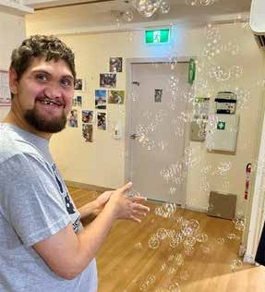
Figure 4: Image DSW Davey and and Team leader Rene hugging and smiling at the camera
Figure 5: Image Participant Tom enjoying his bubble machine

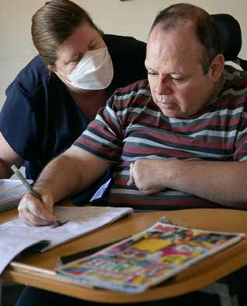
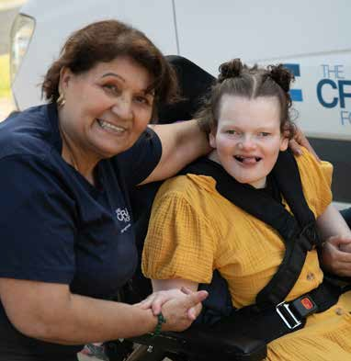
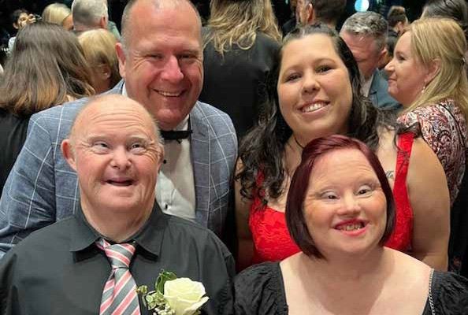
MISSION, VALUES, STRATEGIC PLAN, PERSON CENTRED PRINCIPLE
STRATEGIC PRIORITIES
PURPOSE – Sustainable expansion of services through the provision of homes, meaningful experiences, enablement and community connection to people with diverse, individual needs through the Illawarra and beyond.
1
2
3
CERTAINTY IN DELIVERY – QUALITY & COMPLIANCE
Cram ensures quality of service delivery by challenging the status quo and embedding a strong quality framework. Through our commitment to continuous improvement, exploration of new initiatives and risk- based decision making our actions are in line with the NDIS practice standards.
SUSTAINABILITY AND INFLUENCE
Cram ensures our financial viability and ability to influence through purpose-based decision making, strong fiscal management and putting the participant voice at the heart of everything we do. Investment in the participant experience and measurement of outcomes across our home and living services forms the backbone of Cram’s sustainability and longevity.

ORGANISATIONAL CAPABILITY & CULTURE
Cram drives inclusion and empowerment for people with disabilities by reducing duplication, utilising technology, and improving our methods for day-to-day service delivery. By living our values, building the capacity of our people through education, development and recognition we enhance our culture, grow our profession and make meaningful impact to the world at large.
Figure 6: Image Participant Gabriel drawing with his worker
Figure 7: Image Erica and Participant Amber smiling for the camera
Figure 8: Image Community Industry Awards - Alan, Tara and Participants Richard and Krissy
OUR VALUES
RESPECT We respect each other and every person’s right to inclusion
ACCOUNTABILITY We are accountable for our actions and the Cram Foundation’s long-term future INTEGRITY We conduct ourselves with honesty and transparency
EMPATHY We acknowledge and value each person’s perspective
OUR VISION
A world where each person with a disability can live their best life.
OUR MISSION
To provide person-centred services, high quality homes, meaningful life experiences and relationships.
PERSON CENTRED PRINCIPLE
Underpinning Cram’s values and strategic plan is the principle of person centredness. Cram puts participant experience and quality outcomes at the heart of everything we do. We enable participant engagement, informed decision making and choice in all aspects of our service delivery and ensure a person-centred approach directs the basis of all decisions and initiatives.

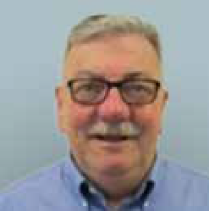
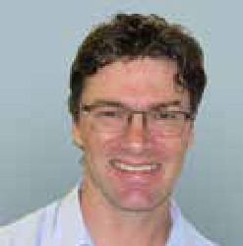
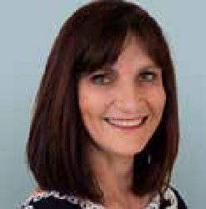
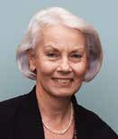
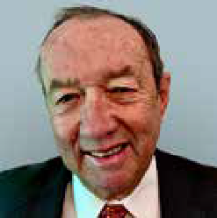
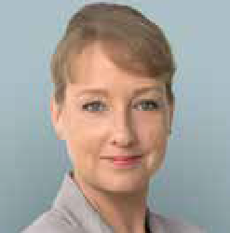
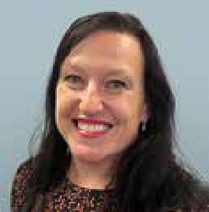
BOARD OF DIRECTORS
Ben Twyford
Director – 2020
Ben is a qualified Chartered Accountant working in the Illawarra for the past 20 years. As a practising accountant he has had exposure to many industries and various local businesses, from which he has developed a broad range of accounting and auditing skills. He is a member of the Illawarra branch of the Salvation Army local business advisory Board. Ben is a member of Cram’s Risk and Audit Board Committee.
Judy Mullan
Director – 2020
Judy Mullan is an Associate Professor within the University of Wollongong (UOW) School of Medicine. She is the Academic Director of the Centre for Health Research Illawarra Shoalhaven Population (CHRISP) and the Deputy Director of the Illawarra and Southern Practice Based Research Network (ISPRN) recognised as one of Australia’s most successful primary care research networks. Judy holds bachelor’s degrees in pharmacy and the Arts, as well as a PhD in Public Health. She is a registered pharmacist and a fellow of the Society of
Hospital Pharmacists of Australia. Judy has made significant professional and research contributions in the areas of health services research, chronic disease management, safe medication management, aged care research, multicultural health, patient education and health literacy. Judy is a member of Cram’s Quality, Safeguards and Clinical Governance Board Committee.
Richard Walsh
Director – 2017
Richard joined the Board in December 2017 and brings with him a wealth of experience in human resources and industrial relations across several industries. Richard is currently the Head of People & Culture Operations for a large, aged care and seniors living organisation (IRT Group) and is also a member of the University of Wollongong HRM Advisory committee. Richard has previously been a director on the board of IRT and he is the Chair of Cram’s People and Culture and Remuneration Board Committee.
Bill Dowson OAM
Deputy Chair – 2017
Bill joined the Board in 2017 and brings significant business and entrepreneurial experience, having both developed and acquired small businesses in the hardware, self-storage and document management sectors. Bill’s community roles have included Salvation Army Red Shield Appeal, Rotary, Illawarra Sports Stadium Trust, Illawarra basketball and Illawarra Academy of Sport. Bill is the Chair of Cram’s Risk & Audit Board Committee.
Linda Wright
Chair – 2009
Linda joined the Board in 2009 and in 2016 took on the role of Deputy Chair and became Chair from 2018. A lawyer specialising in Family Law, Linda is a partner of her law firm based in Wollongong. Linda has been on the management committee of the Illawarra Legal Centre for 23 years, is a Past President of the Wollongong and District Law Society and is involved with the Executive Committee of the Collaborative Family Lawyers Illawarra and Shoalhaven, as well as having held positions on two school P&C committees. Linda is the Chair of Cram’s Quality, Safeguards and Clinical Governance committee.
James Robins
Director – 2020
James was appointed as a director of The Cram Foundation in December 2020. Having formerly resided in the Illawarra for over 15 years, James brings a broad range of experience in leadership, risk management, strategy, information technology and cyber security. Formerly the Chief Information and Digital Officer at Peoplecare Health, James is currently the Chief Executive Officer of HAMBS and is based in Adelaide, SA. He is a graduate of the AICD Company Directors Course and has completed a Bachelor of Science (Computer Science), a Bachelor of Commerce (Management), a Master of Information Science and a Certificate of Executive Leadership. James is a member of Cram’s Risk and Audit Board Committee.
Michael McGrath
Director – 2023
Michael is a lawyer with over forty years’ experience in private practice and in the university sector; most of which was as a partner in Wollongong’s largest law firm. His predominate areas of practice were litigation and mediation, often involving workplace injuries, employment disputes, and acting for persons with a disability. Michael holds bachelor’s degrees in commerce and law together with an Executive Master of Business Administration. He is a past director of several community sporting organisations and is currently the Chair of the Illawarra Legal Centre at Warrawong. Michael is a member of Cram’s People and Culture and Remuneration Board Committee.
Elena Beleska
Director – 2022
Elena joined our Board of Directors in 2022 and brings a wealth of experience to Cram. Elena currently works locally in the Property Development space at IRT. Her professional experience also includes architectural firm work, property development, and eight years working at UOW in both the Planning and the Capital Works teams. Elena has degrees in Engineering, Architectural Technology, Construction Management, and a Master of Business Administration. She is also a member of numerous professional organisations including the National
Association of Women in Construction, Urban Development Institute of Australia, and the Property Council. Elena is on Cram’s People and Culture and Remuneration Board Committee.
Karen Burdett
CEO and Company Secretary - 2018
Karen became CEO in July 2018 and brings over 15 years’ experience in senior roles working with Australia, Asia and New Zealand across a range of industries. Karen’s expertise is Strategic Planning, Innovation, Business Growth, Marketing and Communications within Corporate and Not for Profit sectors. Karen is passionate about delivering excellence in client service and collaboration across community, government, and industry. She holds a Master of Business Administration with Sydney Business School, a Graduate Certificate in Marketing and is a current member of the Illawarra Business Chamber Regional Advisory Committee.

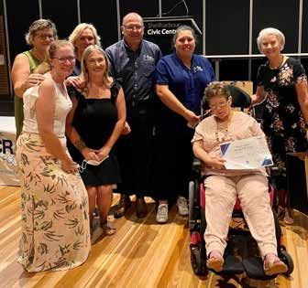
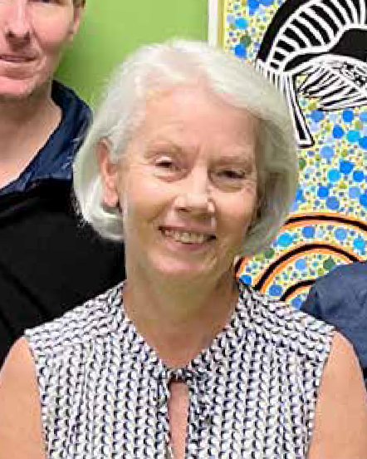
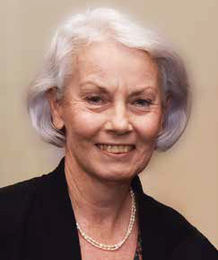
by NDIA and the Australian Network on Disability. The Board also resolved to fund the cost of Company Director Training for any Director who wishes to undertake this extensive additional education.

CHAIRPERSON’S REPORT
Linda Wright

The 2022-23 year was financially challenging. Although predicted, Cram experienced a net loss for the first time in a number of years. While Cram’s Balance Sheet remains strong, vacancies in some Participant homes, reduction in some NDIS funding, staff rostering challenges together with cost-of-living pressures being experienced in the broader community, all resulted in lower income and higher expenses. The Board recognises the ongoing financial challenges facing the disability sector and supports all operational decisions designed to ensure Cram can continue into the future while ensuring Participant welfare is at the centre of each and every decision.

This year has been a busy, but fruitful addition to Cram’s 91-year legacy. I extend my thanks to Karen Burdett - a CEO with immeasurable passion who leads Cram with warmth and humour. Her focus has always been on improving the lives and outcomes of our Participants and she has our full support.
Figure 9: Image Cram Staff Appreciation Event
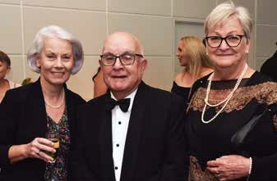

It is hard to believe we are looking back on another year of The Cram Foundation. A year where our community continued to grapple with the COVID-19 challenge, but also the year where we welcomed new Participants, opened new homes, and took on new projects.

COVID-19 continued to affect the organisation during the 2022-23 period. However, our robust policies, procedures, and highly trained staff were effective in the ongoing management of this. It is with deep gratitude that the Board thanks our CEO, Executive team, Team leaders, the supporting staff, and our Disability Support Workers for again rising to the challenge.

The Board continued to meet bi-monthly using a mixture of in person and online platforms to come together. Board members serve on at least one
I acknowledge the deep satisfaction of serving on the Board and involvement in the wider organisation.

During the course of the last year, the payroll audit undertaken in the last financial year was completed. The audit determined that a small number of current and previous staff members had been underpaid and steps were immediately taken to rectify this.

At the end of May 2023, the Cram Foundation took part in their three yearly NDIS and ACIS Certification Audit. This two-day audit covered every aspect of the Cram Foundation – our houses, policies, procedures, and practices. All levels of the business were involved
“
with a physical audit of our premises taking place, along with a review of our documents. I wish to highlight two key areas we were congratulated
on - our People and Culture
Finally, I would like to thank my fellow Directors for their support and assistance over the last year. Bill Dowson, Richard Walsh, Judy Mullan, Ben Twyford, James Robins, Elena Beleska and Michael McGrath all give their time and expertise to ensure Cram has continued to deliver a high level of support to the Participants to enable them to live their best lives.

Linda Wright
Chair
The Cram Foundation Board
Figure 10: Image Cram Board members

Board Committee (Risk & Audit, People, Culture & Remuneration and Quality & Safeguarding).
These committees are in place to inform and report to the Board on each of these specific areas. The Chair also attends and chairs the Culture Committee which is made up of staff representatives and
two Executive members. These committees are integral to ensuring correct governance is

It is comforting to know that the right people, with the right skillsets are employed at Cram.
processes and procedures and the implementation of our Practice
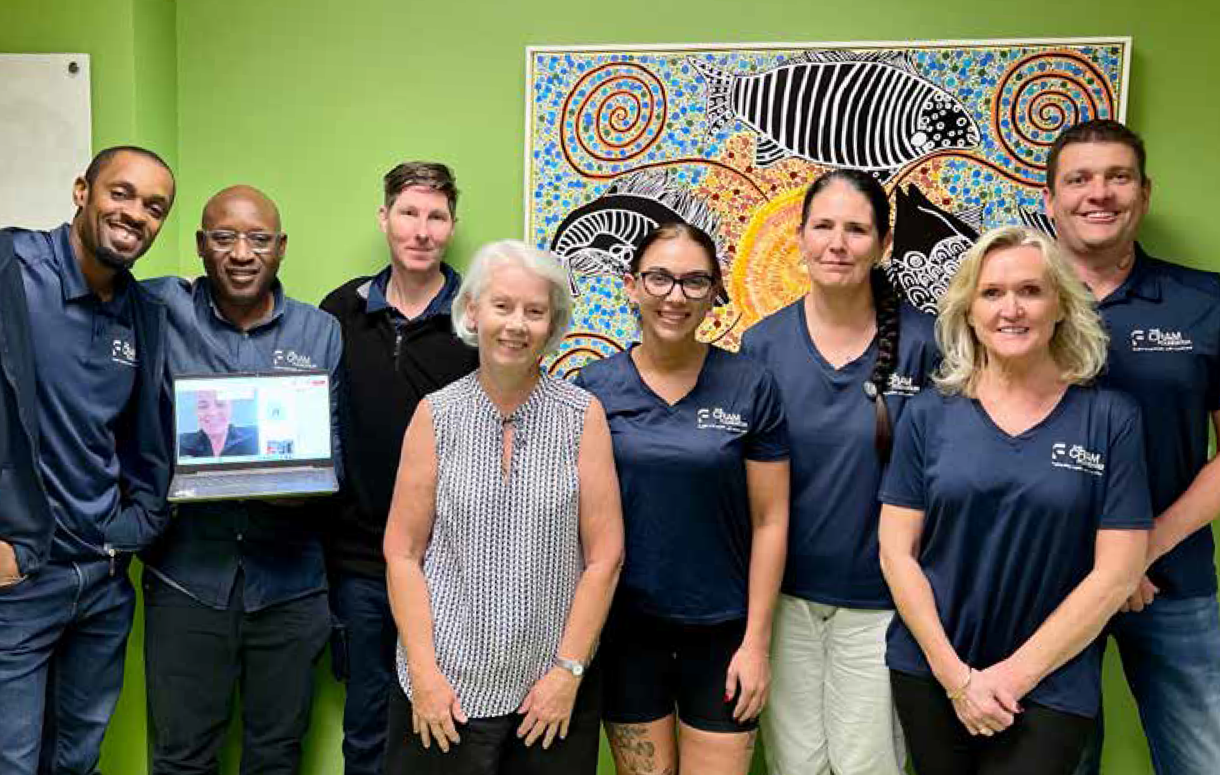
Management. It is comforting to know that the right people, with the right skillsets are employed at Cram.
Figure 11: Image: Cram Culture Committee

The past year also saw the opening of 10 Chaplin – a purpose-built home housing four new Cram Participants. The board is incredibly proud of
10 Chaplin. It was planned and developed with the Participant in mind, and we believe it is the future of the disability sector. It speaks to our person-centred principle and the plans for the development of the block next door will follow the same blueprint.

taking place.

During the year the Board resolved that all Directors become members of the Australian Institute of Company Directors. Membership of this organisations provides opportunities for Directors to attend courses and webinars, undertake training and receive relevant and timely updates about matters relating to governance and responsibilities. Directors have also had the opportunity of participating in various webinars run by NDIA and the Australian Network on Disability. The Board also resolved to fund the cost of Company Director Training for any Director who wishes to undertake this extensive additional education.

The 2022-23 year was financially challenging. Although predicted, Cram experienced a net loss for the first time in a number of years. While Cram’s Balance Sheet remains strong, vacancies in some Participant homes, reduction in some NDIS funding, staff rostering challenges together with cost-of-living pressures being experienced in the broader community all resulted in lower income and higher expenses. The Board recognises the ongoing financial challenges facing the disability sector and supports all operational decisions designed to ensure Cram can continue into the future while ensuring Participant welfare is at the centre of each and every decision.

This year has been a busy, but fruitful addition to Cram’s 91-year legacy. I extend my thanks to Karen Burdett - a CEO with immeasurable passion who leads the Cram with warmth and humour. Her focus has always been on improving the lives and outcomes of our Participants and she has our full support.
Finally, I would like to thank my fellow Directors for their support and assistance over the last year. Bill Dowson, Richard Walsh, Judy Mullan, Ben Twyford, James Robins, Elena Beleska and Michael McGrath all give their time and expertise to ensure Cram has continued to deliver a high level of support to the Participants to enable them to live their best lives.

Linda Wright
Chair
The Cram Foundation Board
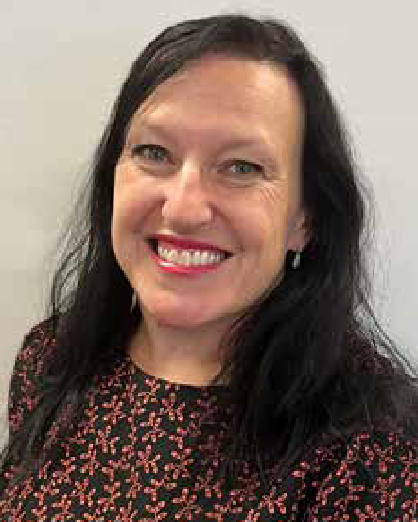
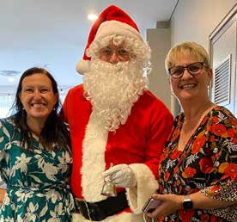
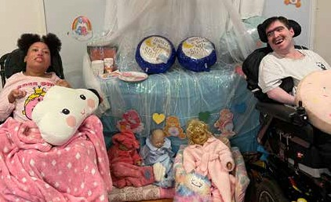
Regarding Cram’s financial performance for the year, we are pleased to post a small surplus for the year. This is despite many significant fiscal challenges through the year with changeable funding, increased labour costs and costs attributed to inflation and ongoing covid management. Moving into a new year we are projecting a budgeted loss partly due to the ongoing changes and constriction on NDIA funding but also due to proactive development and allocation of funds towards enhanced systems and additional resources in the areas of quality, Participant experience and supervision.

CEO UPDATE
Karen Burdett
Figure 12: Image CEO Karen Burdett and Linda Pullen smiling with Santa
Figure 13: Image Participants Jordan and Michael smiling on PJ Day
which offers great opportunity for innovation and enhanced inclusion. Overwhelmingly, the organisation will continue focussing on providing the best possible care for our Participants, assisting them with their goals through transparency and accountability.

I’d like to personally extend my thanks to Cram’s exceptional Board Chair Linda Wright and other seven Directors who give freely of their time and skills as volunteers to contribute to the strategic development and success of this long-standing organisation. Their unwavering support

This past year, my fifth at Cram, has again been one of exciting developments in the home and living space, some challenges, and many experiences of Participant joy. I am hugely grateful for the opportunity to lead this organisation and wholeheartedly believe in supporting our Participants to achieve their person-centred goals.

COVID-19 has still featured heavily in the operations of The Cram Foundation over the past year. We relied on our dedicated COVID-19 Management plan to inform our processes and I would like to thank our staff and Participants and families for working with us through these challenges.

I have been so pleased to see our Participants back out in the community again! As COVID-19 restrictions eased, we were again able to actively increase our Community Participation. It has been wonderful to see the effects of in-person activities and the positive interactions our Participants are having once again. One of the amazing programs we’ve been able to start back up again is our Men’s Group
– spearheaded by our Team Leaders. This group was developed to bring together our cohort of male Participants to increase their capacity building skills. This past year has seen them attend a number of outings and execute multiple Bunnings BBQs as a fundraising activity with
the goal being to develop tool kits for each home where they can manage small repairs. Several Participants of the program have actively engaged in building capacity in assisting in the running of the BBQ, learning new skills such as money handling and customer service. They have big plans for this group and I’m excited to see what happens next year.

For the first time in three years, Cram staff were able to engage in offsite team building, a chance for our houses to spend some time together away from work. I was delighted to see all our teams come together and successfully (or unsuccessfully) navigate the escape rooms in Wollongong and share a meal together!

I’d like to acknowledge the ever-changing work environments with new Participants, new properties and the continuance of complexity related to ongoing challenges of COVID-19 for our frontline and
support staff over the past year. I commend them for their adaptability, in demonstrating enormous resilience and dedication to Cram.
This year also saw two additions to my Executive team. Lena Blinko as Executive Manager, Home and Living and Sarah Mason, Executive Manager, Marketing and Communications. These new appointments are in direct correlation to the growth Cram has experienced recently and, along with the current Executive team will play a crucial role
in shaping the organisation’s future direction, against a changing landscape. I want to acknowledge the Executive team’s contribution to Cram over the last year, always going above and beyond to ensure the job gets done and showing that teamwork and collaboration at the leadership level always ensures positive outcomes.
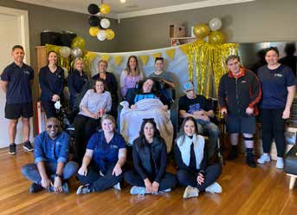
Figure 14: Image 10 Chaplin staff and participants smiling at the camera

In June this year we celebrated the1st anniversary of our Chaplin site – a huge milestone and one I am immensely proud of. We have seen the Participants flourish in their new home and I look forward to seeing how we iterate on this design for the block next door. Cram
welcomed ten new Participants and families this year and we also said goodbye to some much-loved Participants and were honoured to work with their families to ensure their final moments were full of care and love. One Participant passed away due to Huntington’s Disease which strengthened our commitment to raising awareness for this disease. We were proud to participate in the Walk 4 Hope in 2022 to raise money for research into this disease and will walk again in 2023.

Reviewed in February 2023, Cram’s 3-year Strategic Plan that details objectives and key performance indicators (KPI’s) to monitor performance. These objectives are met by the implementation of
an operational roadmap of key initiatives which detail actions and assignment of resources, both financial and human, that align to the strategic objectives and priorities.

The Cram Foundation’s strategic objectives are centred on achieving certainty in service delivery through a strong focus on quality and compliance, investment in organisational capability and culture, and sustainable growth and influence across the sector. Underpinned by its person-centred principle, Cram is constantly working towards an innovative approach to participant-led support, inclusivity, and flexible design in its support environments. Cram awaits the finalisation of the National Disability Insurance Scheme’s Home and Living policy for guidance on future funding models for supported independent living.

Effective governance is maintained through established procedures validated by external audits appropriate to the disability sector which include Cram’s most recent major NDIS and ACIS recertification audits. I’d like to personally thank our team for the extensive involvement of all levels of staff and Cram’s Deputy Chair of the Board Bill Dowson for their efforts with the audit.

The next year will be even busier than the last with work to begin on our first ever Reconciliation Action plan, continued participation in the release of two industry reports. The findings of the Royal Commission
into Violence, Abuse, Neglect and Exploitation of People with Disability revealed 222 recommendations and Cram has been pre-emptively preparing for ways in which we will adapt to such recommendations and how we can raise the bar of or service standards and governance. The Independent Review of the National Disability Insurance Scheme is due to release its findings in October 2023. Both these pieces of work will signal a profound shift in the way Cram currently does business

and guidance towards myself and the team through many sector unknowns, challenges and successes are truly appreciated. I am proud of the work we have done together over the past year on reviewing our Governance practices and look forward to evolving how the oversight of the organisation to enhance and deliver quality person-centred outcomes.

I want to acknowledge Cram’s Participants, families, guardians, and carers for working alongside us to provide the best possible service delivery. I also want to thank our community supporters, partners and all who hold Cram in such high regard.
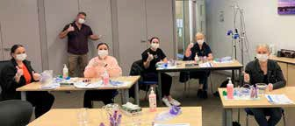
Figure 15: Image Staff attending Cram Internal Training

Lastly, my heartfelt thanks to our Disability Support Workers, Team leaders and Administration staff. We are a dynamic and adaptable organisation that is actively engaging with the community, navigating regulatory changes, expanding its services, and strategically appointing new leadership to address evolving challenges in the disability sector. I am proud of our tenacity and look forward to the year ahead.

Best wishes

Karen Burdett
CEO, The Cram Foundation

PARTICIPANT HIGHLIGHTS
In the past year, our Participants have achieved many of their personal goals - Congratulations! With the easing of COVID-19 restrictions, they have been able to get back out into the community via Community Participation, start attending centre and seeing their families again.

Some of the key achievements of our Participants are below, congratulations to all our Participants:
- Krissy and Richard became new flat mates and are digging each other’s company. Plus, Richard also met the Governor General of Australia! A huge honour made possible through his involvement in the Rotary Club.
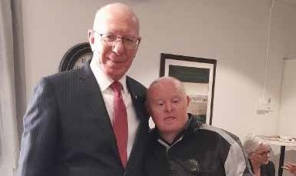
Figure 16: Image Govenor General and Participant Richard

- Stephen was able to get back into the pool after many years and is loving the water again!
- Cheryl holds the honour of attending more concerts than any other Participant at Cram! From classical concerts, musicals, cover bands like Elvis and Elton John - her love of music is unmatched, and she can be found regularly grooving along to Elvis on any given day.
- Liz, Ash, and Kate have been enjoying their new purpose-built sensory room complete with lights, music and sensory objects in their home.
- Baz is enjoying getting out and about in the Community.

In a fully inclusive and accessible world, my Participants would be able to access the supports they need to live the lives they want.
Cram Support Coordinator

- Lydia has been enjoying extra quality time with her family with the installation of a new lift being installed specifically for her.
- Michael reconnected with family with regular catch ups and FaceTime sessions.
- Sharon expanded her artistic skills and beautiful craft creations and put her event management skills to use along with Eloi, Steven, Sharon, and Elisa arranged a super party celebration.
- Vanessa celebrated her big five 0 and partied on the dance floor at The Illawarra Business Awards.
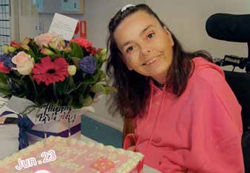
Figure 17: Image Participant Vanessa
- Jordan hosted a significant birthday with a party and celebrations with her friends and family.

YEAR IN REVIEW

2022
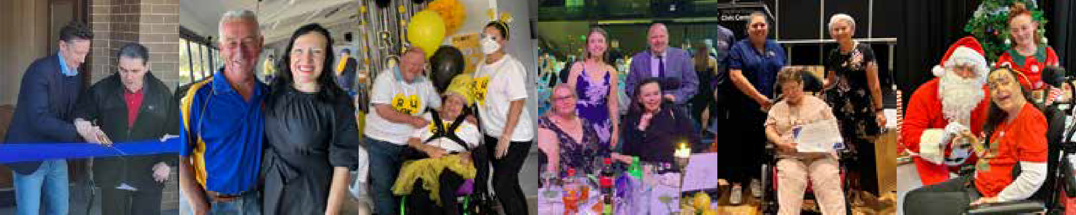  JULY  Figure 18: Key events throughout 2022 | AUGUST | SEPTEMBER | OCTOBER | NOVEMBER | DECEMBER
Opening of Chaplin site Opening of Chaplin site | Design principles workshop held with regional leaders including valued input from the late Dr Justin Yerbury  Pyjama day  Sea Eels Cram Staff Appreciation Day -  $2000 donation | R U OK? Day  Shoalhaven Disability Expo | Cram Finalist in the 2022 Business Illawarra Awards  Huntington’s Walk 4 Hope  One Door Mental Health Lunch – Cram Sponsorship  Payroll audit and system review | Cram’s 90th anniversary – Community Gala dinner and Staff Recognition Event | Participant and Family Christmas party  International Day of People with a Disability  Sponsorship of Accessible viewing platform for  New Year’s Eve, Wollongong Council

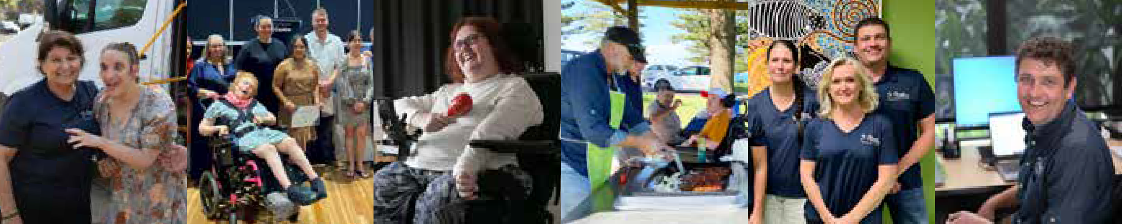
“
2023
JANUARY | FEBRUARY | MARCH | APRIL | MAY | JUNE
Sponsorship of Accessible viewing platform for 26th January, Wollongong Council | Staff recognition event  Board Strategic Planning Day | Launch of Music Therapy Program  Launch of The Voice, Employee Survey | Cram Men’s Group Bunnings BBQs  Executive Manager, Home and Living commenced.  Easter celebrations | Practice Leadership launch | Tully Disco  Staff team building resumes again!.  Executive Manager, Marketing and Communications commenced.  NDIS and ACIS  Major Recertification Audit achieved  with zero non- conformance.

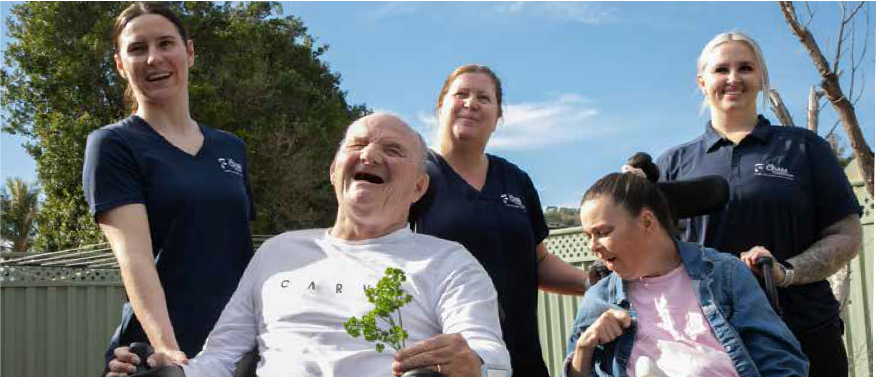
Figure 19: Image 19 Darling Mills Participants and Staff smiling

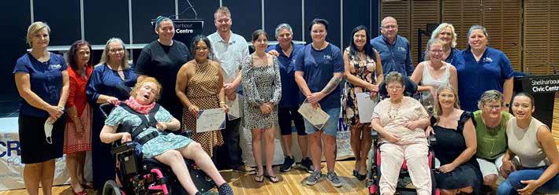
Figure 20: Cram Staff Appreciation Day

Support Coordination at Cram
The Cram Foundation has a dedicated Support Coordinator who acts solely in the best interests of Participants. Cram has offered this service since the implementation of the NDIS. Cram’s Support Coordinator goes to great lengths to establish strong relationships with the Participant and a detailed knowledge of their needs to achieve their NDIS
plan goals. and their professional background gives them a unique understanding of what our Participants need to flourish. The role supports a number of Participants, which means managing their plans, their plan reviews and connecting their Participant to relevant services, equipment or supports that they might need.

Put simply, our Support Coordination service assists Participants and their families to navigate the NDIS. It can be challenging for a Participant and their family to understand the intricacies of a NDIS plan. Asked what their Participants and families need the most help with, our Support Coordinator said, “Plan Reviews! Making sure we provide the NDIS with the right reports and data to secure the funding they need. Also linking the correct services to achieve Participant goals”. Without the correct funding, Participants can’t get the supports they need to live their best life.

This role is central to bettering the lives of people with disability and is proud to be able to offer this service Participants as a critical service.
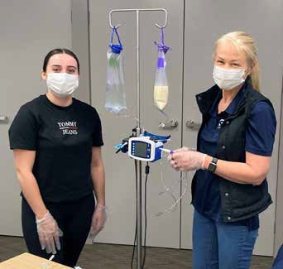
Figure 21: Image Staff Internal Training

Growth, Innovation, and Quality Service Delivery
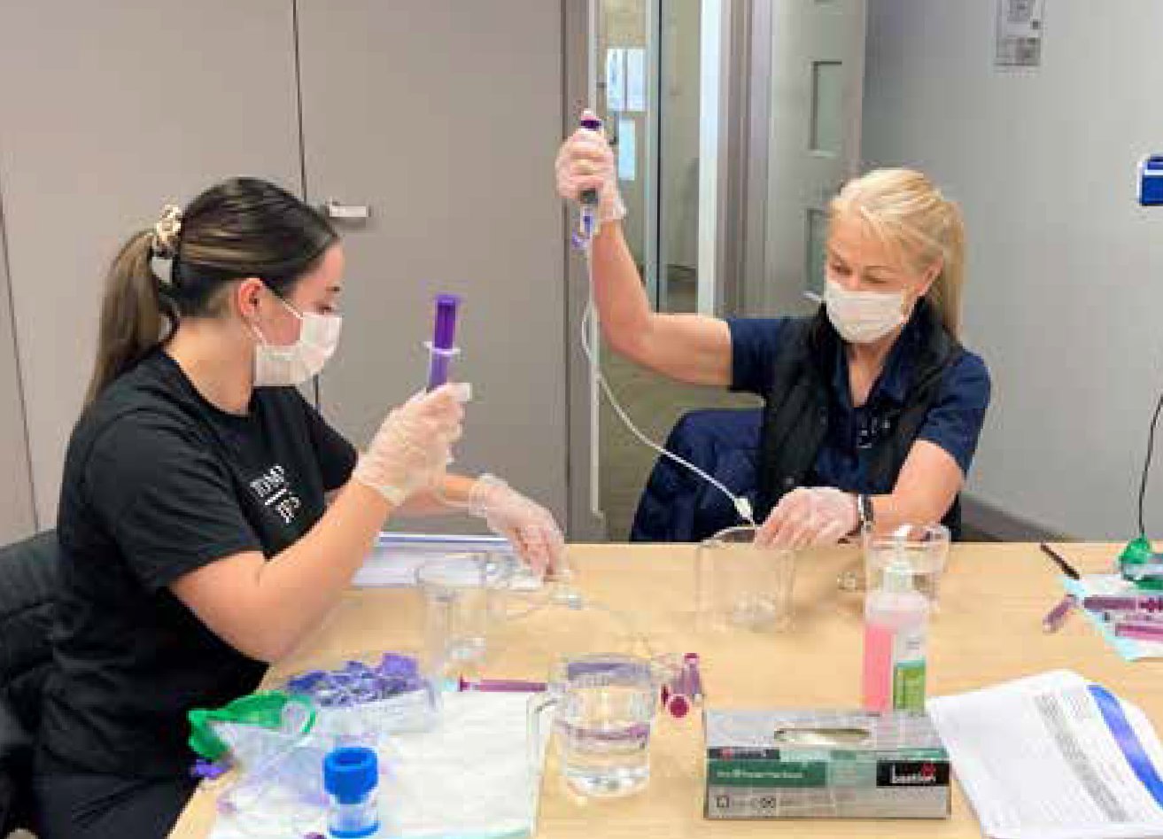
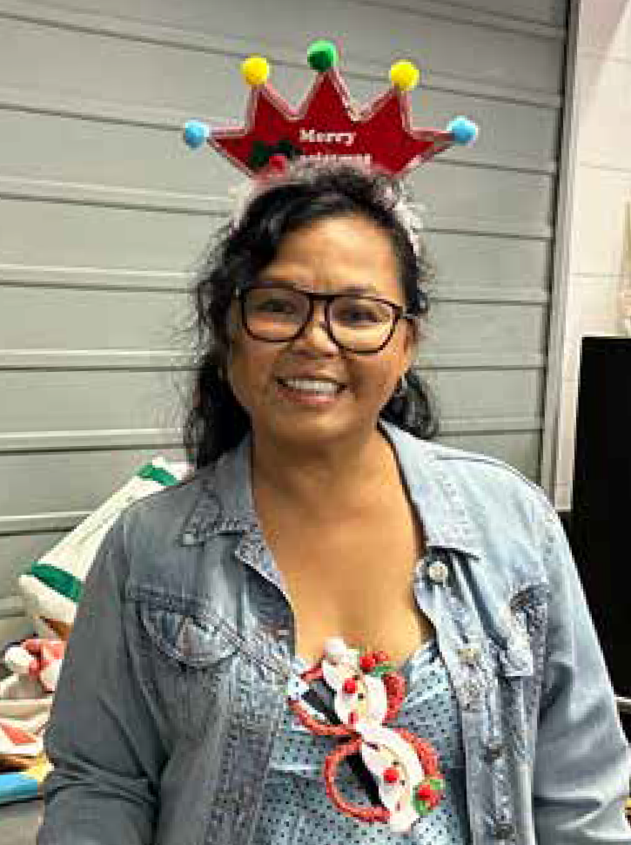
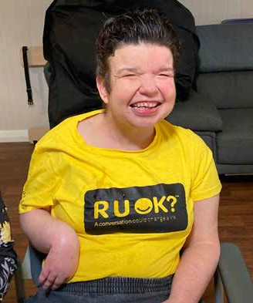
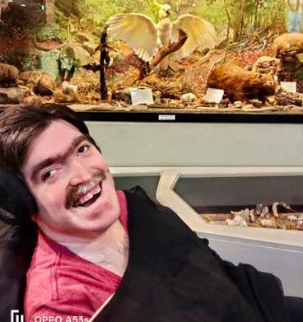
The Cram Foundation continued to make progress with our Strategic Focus of Growth, Innovation and Quality Service during the 2022/23 year. Cram has onboarded a total of 10 Participants, including 9 Supported Independent Living (SIL) Participants and one Community Support Program (CSP) Participant. We saw our newest site Chaplin celebrate its 1st anniversary and the development and planning begin for Cram’s adjoining block. This modern building is the benchmark for all future accommodation at Cram.
“
“

The upskilling of staff is crucial in ensuring that they can provide high-quality care to Participants.
When employees are well-trained and informed, it translates into improved care delivery and better Participant outcomes.

In May this year, Cram successfully navigated our NDIS and ACIS certification audit, which occurs every three years earning
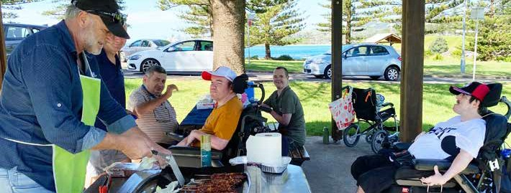
commendations in our People and Culture processes and procedures and our Practise Leadership implementation.
Figure 22: Images of Cram Participants in the Community

The introduction of Practice Leaders shows our commitment to improving the skills and expertise of our staff. These leaders now serve as mentors and trainers to other Disability Support Workers (DSW’s), helping the team develop critical skills and knowledge for our organisation.

The upskilling of staff is crucial in ensuring that they can provide high- quality care to Participants. When employees are well-trained and informed, it translates into improved care delivery and better Participant outcomes.

During the past year Cram has also introduced a Program of Supports, offering a personalised and flexible approach to delivering services to Participants. By tailoring support to the unique needs and preferences of our Participants, Cram is enhancing the quality of care provided. This customisation is another area we are focussing on to deliver Participant satisfaction.

Cram’s interest in exploring how Assistive Technology (AT) can complement DSW’s has increased over the past year. We believe that integrating AT into our service delivery can lead to more efficient and effective care. AT can help automate tasks, enhance communication, and provide additional resources to support Participants, ultimately improving Cram service delivery.

The organisation aims to integrate assistive technology to support the Direct Support Worker (DSW) workforce. This could involve the introduction of tools and technologies to enhance the efficiency and effectiveness of care delivery.

As we already look towards the next year at Cram, we are focused on three key outcomes.

New Home Design Improvement: The completion and delivery of the Chaplin development is a major focus for Cram. The organisation plans to complete the project by 2024 to enable more bespoke accommodation for our Participants. Cram has dedicated time and effort throughout 2022/23 to enhance the design principles around the Chaplin build to ensure high quality standards. During the next year, an architect will be appointed, and the project team will bring together our current Participants to take part in a design workshop to inform the lay out and functionality of the build. Involving our Participants ensures we are continually iterating on the design process, ensuring alignment with Participant needs and preferences.

Greater Flexibility for Participants in Fund Usage: Offering Participants greater flexibility in how they use their funds is a commitment Cram has made to person-centred care. It means Participants will have more control and choice in how their resources are allocated to meet their individual needs and goals. This approach aligns with the broader shift towards Participant-directed services and will enhance overall satisfaction and outcomes for Participants.

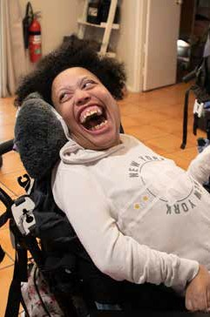
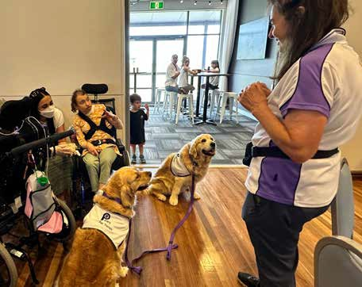
Cram believe these initiatives reflect a commitment to improving service delivery, Participant empowerment, and the integration of innovative solutions.
Figure 23: Images of Cram staff and Participants

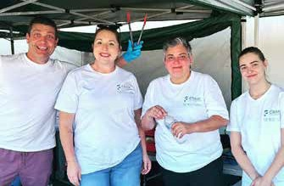
Property Acquisition: Cram continues to build on its portfolio and will commence delivering services in two properties in the Dapto area, slated to open early 2024. This activity will feed into our 5-year Housing Strategy continuing to grow Cram in an ever-changing industry.
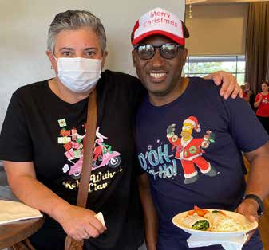

PEOPLE AND CULTURE
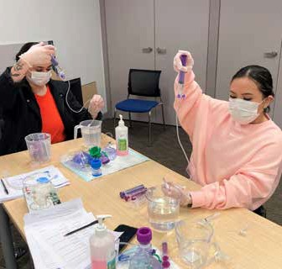
Our People and Culture team have navigated numerous challenges and changes over the past 12 months with legacy systems. Managing the effects of COVID, a growing workforce against an increasingly difficult recruiting landscape and all their BAU activities. They have done this whilst maintaining a positive culture with their team and throughout the organisation.

Cram Committees
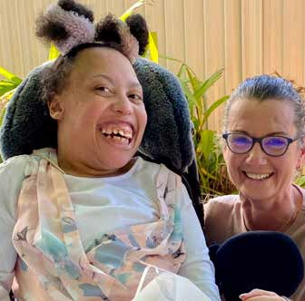
Cram operates staff committees to provide overview, feedback, and ideas across the organisation. Members of Cram’s Board of Directors, Support staff, Team leaders, Executive management, the Administration team sit on these committees to ensure they are reflective of the diverse nature of our staff. Each committee member can then provide information back to their respective team and convey information on behalf of their teams.
Figure 24: Image Participant Jordan turns 30

Work Health and Safety Committee
Nine Cram staff representatives from the Work Health and Safety Committee who explore opportunities to increase health and safety across Cram and deliver on new projects and initiatives to achieve this. They are involved in COVID-19 policies and procedures, reviewing incidents, identifying hazards, mitigating risk, and making
improvements across sites. We appreciate their commitment to working with management in ensuring the health and safety of our staff and participants.

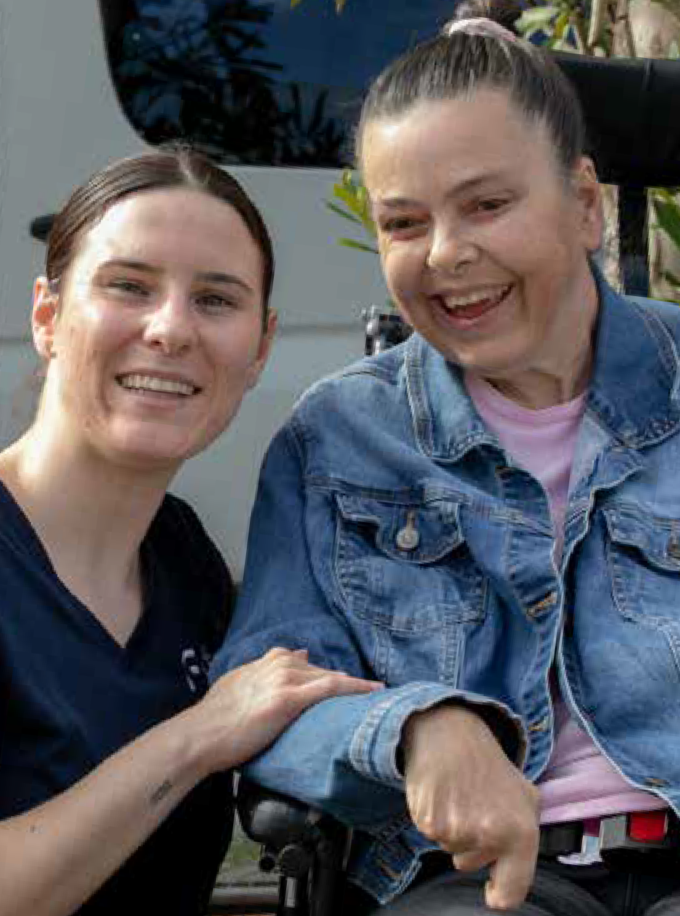
Figure 25: Image Participant Vanessa and staff

Culture Committee
18 staff members are part of the Staff Culture Committee at Cram, which is led by Linda Wright, Cram’s Chair. This committee provides a focus
on staff engagement, positive workplace culture, as well as activities and initiatives throughout the year. This committee was a key driver in the successful Harmony Week and R U OK? Day events that bought together Participants, staff, and houses to celebrate our connections and provide support. A calendar of events was created by the Culture Committee to track ideas and plans for events and provide an overview of the year’s activities.

The Committee also provides valuable input on organisational policy, systems, new initiatives to enhance respect at work, skills development for our staff, input to Cram’s brand and our important leadership role in the community.

Looking ahead, The Cram Foundation has commenced consultation regarding the development of its first Reconciliation Action Plan.

TENURE MILESTONES:
Between the 14 Cram staff members that received Tenure Milestone awards, have a combined 125 years of service between them.
Cram is very fortunate to have such a high level of experience and knowledge among our dedicated staff.
5 YEARS | 10 YEARS | 15 YEARS | 20 YEARS
- Michelle • Jodie King  Szutowicz • Obouko  - Breanna Agnatson Carney • Maria Marsh  - Debra • Michaella Cambourn Memmo  - Debbie Cohen | - Lynette Lawson  - Ashley Angus | - Linda Solitro  - Antonia Vasquez  - Jodie Street | - Magi  Voorwinden
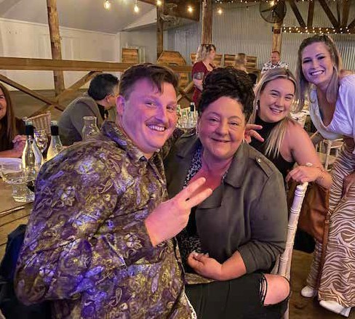
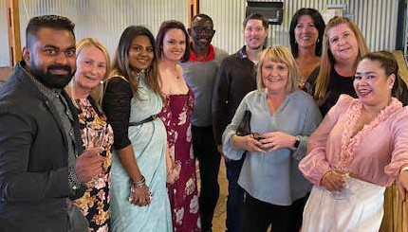
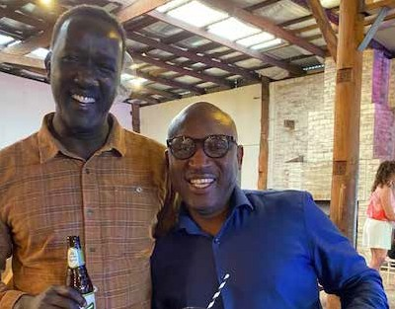
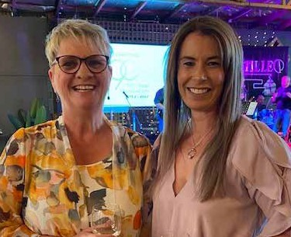
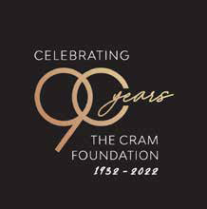
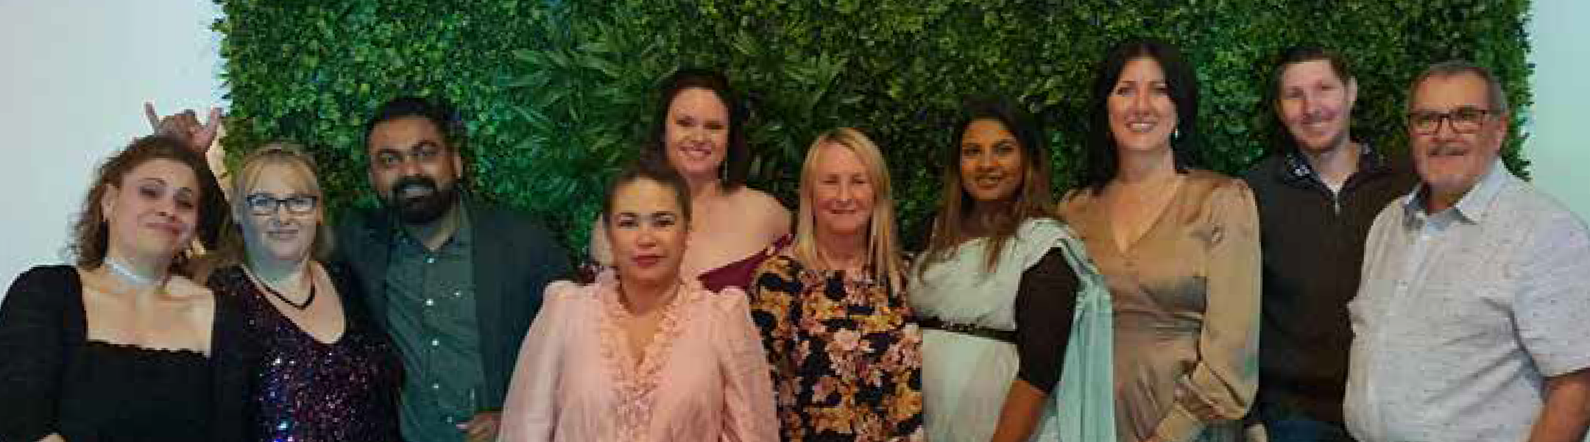
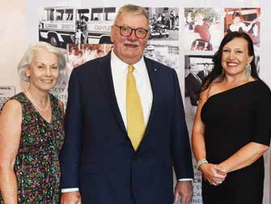
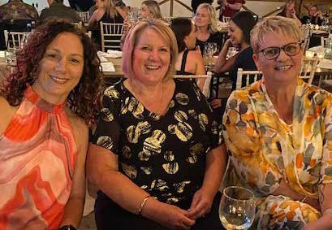
Figure 26: Images Cram's 90th Anniversary Staff Party
Table 1: Cram P&C statistics for the year
45 New Staff Hired
11,448
Over Time Hours Worked
6 Induction Groups Held
113 Interviews Held
6 CEO Updates:
Our health Support team worked
over 3000 hours during the period.
2 staff were successfully recruited internally
3,005
Number of nursing hours

COVID-19 Management
Cram’s dedicated COVID Management Plan aligns with Government and Public Health Orders, providing directives on how to comply with orders and advising on updates and changes to advice. It is updated frequently to ensure the most current requirements are reflected
and has been the key source of COVID management information during this time. The Cram COVID ambassador program also continued in 2022/23, providing another avenue for staff to access information, share ideas, and monitor COVID policy implementation. The ambassadors supported the implementation of COVID-related strategies within Cram sites and passed on feedback regarding implementation and further health and safety strategies.
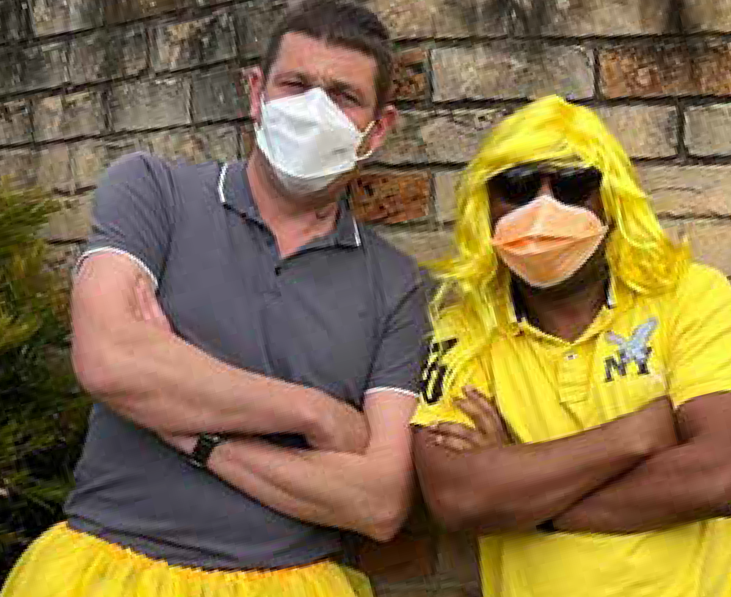
Figure 27: Image Team Leaders Scott and Archer on R U OK? Day

Recruitment & Induction
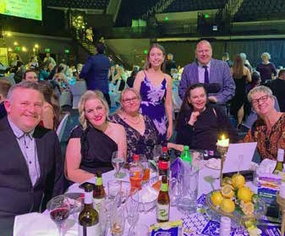
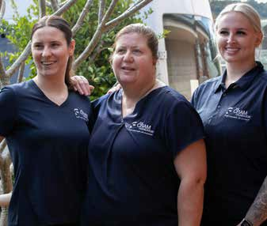
The Cram Foundation held 113 interviews, ran 6 inductions, and onboarded 45 new staff members including Disability Support Workers, administrative team members (Human Resources, Accounts, and Marketing), Team Leaders, and Nightshift Coordinators. Cram has further developed its recruitment strategy and revisited in-person expos and job fair events to promote the benefits of working at The Cram Foundation and gain access to active job seekers. The listings of jobs online on both the Cram and Seek websites, as well as on local job boards has continued.
Figure 28: Image Illawarra Business Awards

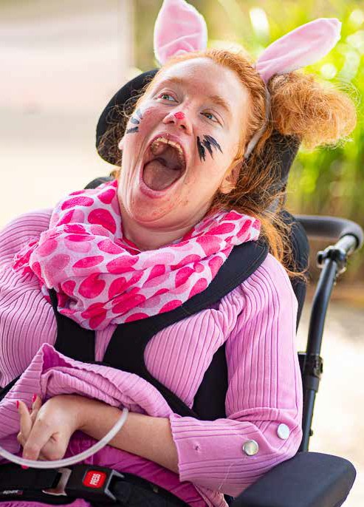
Figure 29: participant Laura dressed as the Easter Bunny
Cram was a key employer featuring in the CareForce Program, a
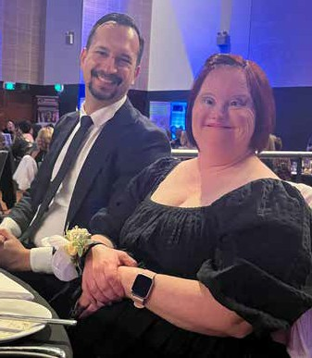
12-month program run by Community Industry Group to connect local care industry employers directly with job seekers. Cram exhibited at CareForce expos, submitted videos promoting Cram to their online events, and pledged jobs to their job board. Cram continued with a strong focus on training and support for both new and current staff, ongoing training opportunities, and consulted directly with staff on key decisions and changes.
Figure 30: Image Vedran and Participant Krissy

SURVEYS
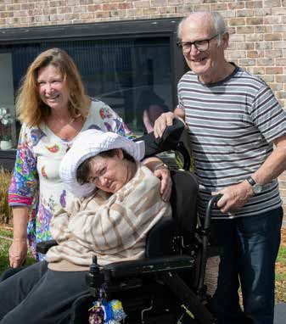
Figure 31: Image Participant Jess and her parents

Participant and Family
Cram distributed a Participant, Family and Carer Feedback survey requesting responses to a range of questions regarding Cram’s service, facilities, and customer service. Communication with participants and families continued to be a key element of Cram’s service strategy. The survey communications also invited any participant or family member to meet with Cram’s CEO directly to discuss any feedback, further fostering the culture of open communication, trust, and continuous improvement.

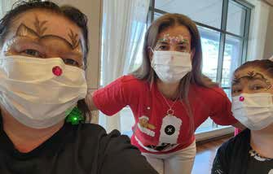

Staff
Cram staff completed an all-staff survey in April this year covering a range of topics under three main banners – engagement, wellbeing and progress. The aim of the survey was to ascertain a benchmark for future surveys to enable progress. An action plan has been developed out of the feedback received and staff will continue to receive regular updates about milestones being reached.

Awards
The Cram Foundation was a finalist in the 2022 Business Illawarra ‘Excellence in Customer Service Award’ and ‘Outstanding Community Organisation Award’ categories. This external recognition celebrates our staff’s ongoing efforts and increases the positive brand recognition of Cram in our wider community. Cram were also recognised for their sponsorship of the Accessible Viewing Platform on New Year’s Eve and Australia Day at the Lord Mayor’s Recognition Event.

2023 Staff Recognition Event
Cram again hosted its annual recognition event in February to highlight the achievements of staff and to mark staff milestones. This year, a new award was given, The Cram Champion Award awarded to Nightshift Coordinator, Christine Cross based on the amount of staff nominations she received and her exemplary professionalism and commitment to her role, our Participants and her colleagues.

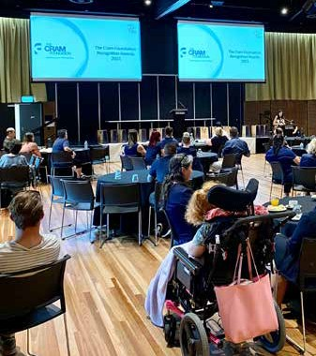
Figure 32: Image Staff Recognition Event

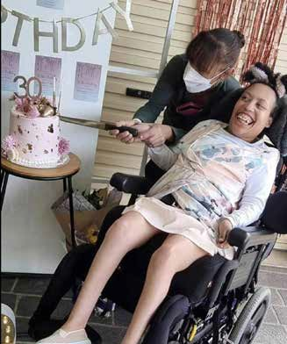
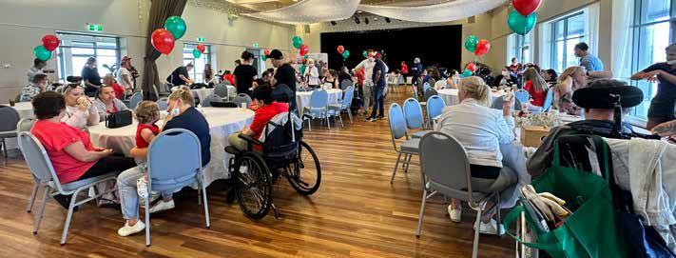
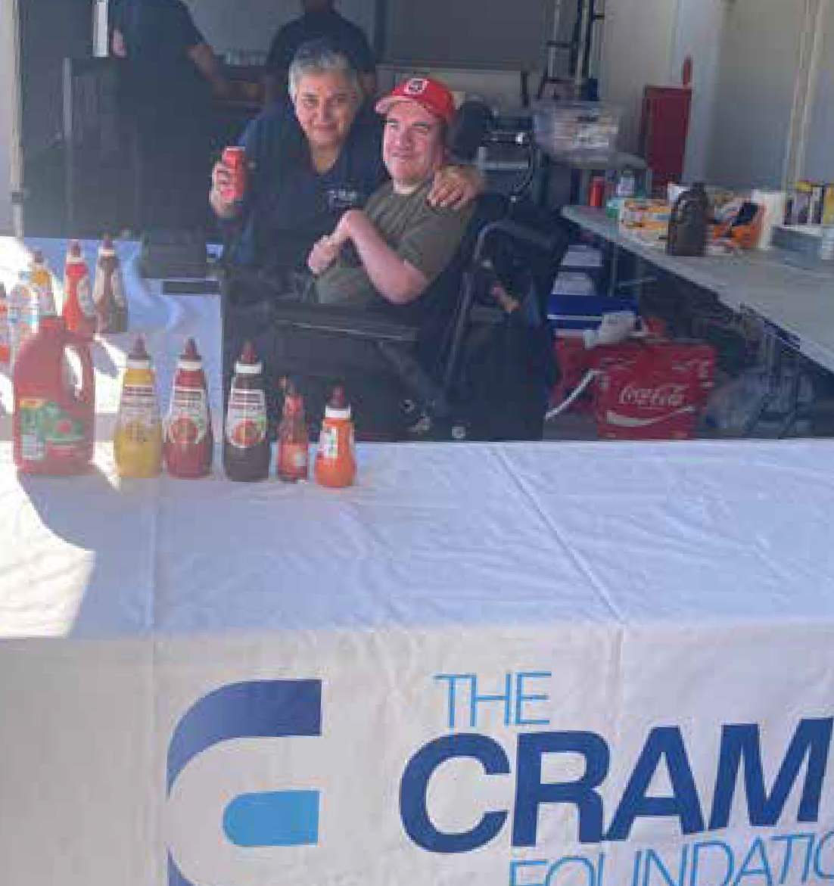
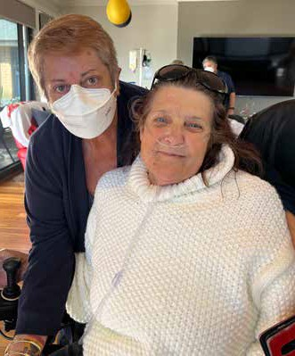
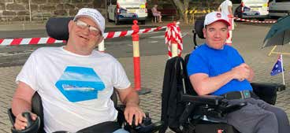
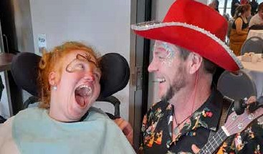
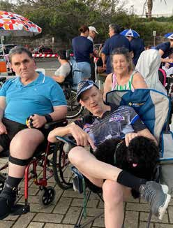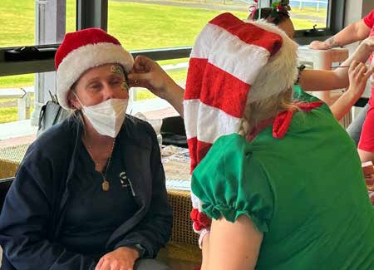
Figure 33: Images Staff and Participants attending events throughout the year
Figure 34: Images of Staff and Participants in the Community
STEP UP PROGRAM
A number of training opportunities were offered to Cram staff to upskill and expand their qualifications. Cram continued to offer the Cram Step Up Leader Program, which provides access to mentors and exposure to many areas of the business, developing knowledge, experience and skills. This program is aimed at staff who have leadership aspirations and are looking for further career development opportunities. Cram’s commitment to provide these opportunities to staff has made this program extremely successful.
Total Number of Training Events attended/Number of Training Programs held
(18 types of sessions)
- High Intensity/Emergency Evac Training & Bullying/Harassment Training (7 sessions)  - HSR Training  - Accidental Counsellor  - BISP Training  - Gastro Training  - Hydro Rescue | - Mealtime Management  - Person Centred Training  - Behaviour Support Training  - Enema Training  - Gastro Training  - Participant Training | - Oral Suctioning  - Transition Plan Training  - Manual Handling  - Midazolam Training  - Complex Bowel & Digestion  - Lunch and Learn
Online Modules – Refresher Training (15 learning modules)
- Epilepsy Management  - Complaints Handling Process  - Cross Infection  - Covid-19 Update Training  - Documentation | - Skin integrity  - Role of the OCV  - Restrictive Practice  - Participant Privacy and Dignity  - Outbreak Readiness | - On Call and After Hours  - NDIS Videos  - Medication Modules  - Human Rights Leaning Module  - Human Resources Module
TOTAL = 33

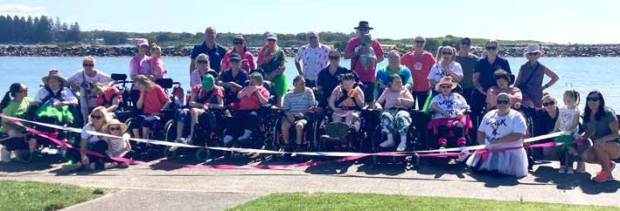

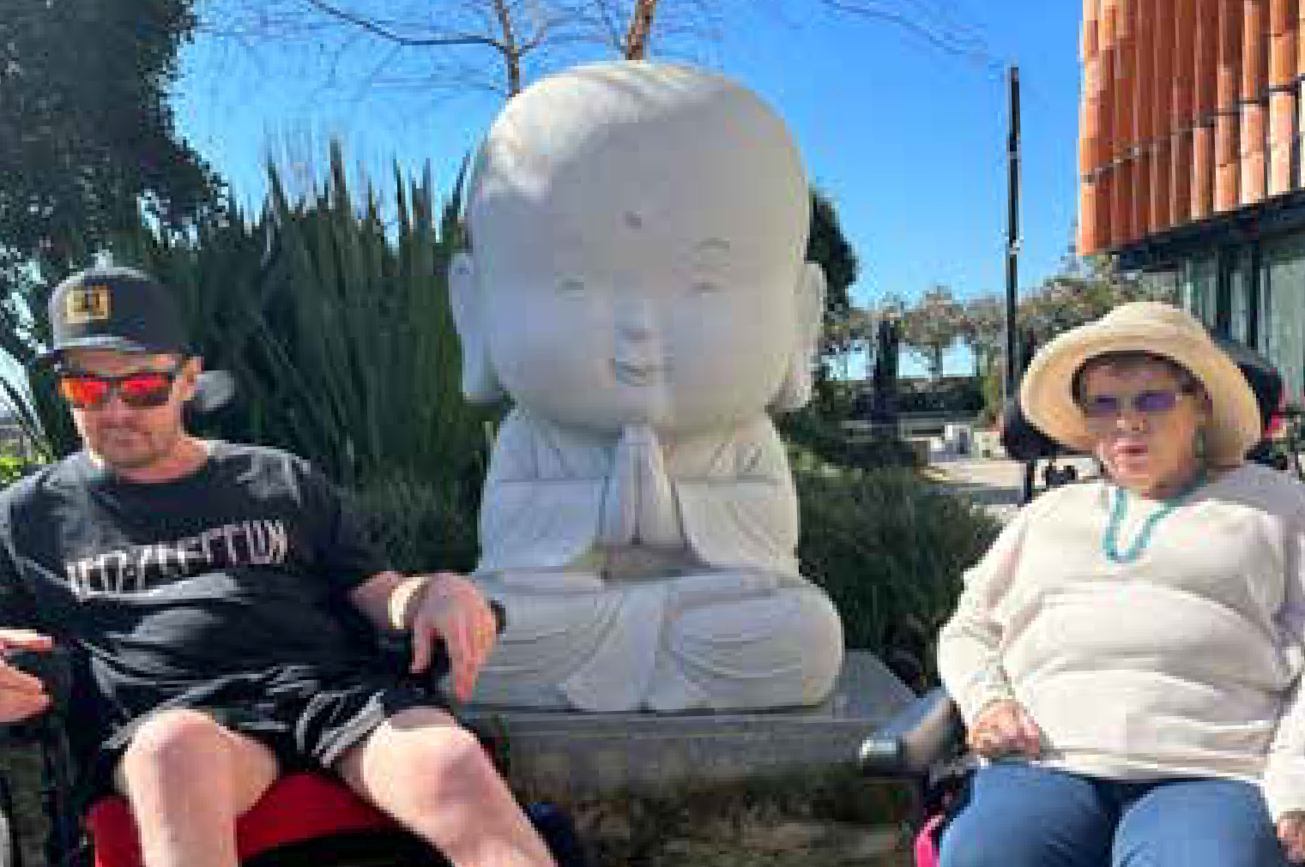
CRAM IN THE COMMUNITY
With the easing of COVID-19 restrictions over the past year, Cram has been so pleased to start heading back out into the community. We have started new programs, seen our Participants return to Community Participation and we’ve also picked up where we left off with some of our wonderful supporters.

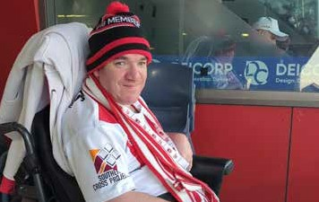
The Cram Foundation again advocated for people with a disability both in our local communities and on more of a national scale. Engaging with the government, politicians, and other community organisations on all disability related issues. Over the past year we have worked with Wollongong City Council to provide specific feedback on events and procedures, so our Participants had a voice. Cram continue to be part of the Illawarra Disability Alliance with CEO, Karen Burdett regularly attending their meetings. This group of not-for-profit disability service providers work together to ensure better outcomes for people with a disability and the industry as a whole.

Cram continued its relationship with many business and community groups, attending industry events and maintaining key memberships.
- Business Illawarra
- Illawarra Disability Alliance
- Illawarra Women in Business
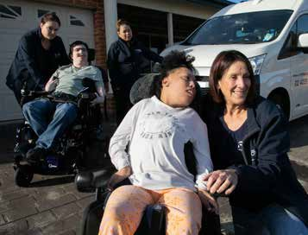
- The Illawarra Connection
Figure 35: Images of Cram in the Community
- Attended the Illawarra Disability Options, Shoalhaven Disability Options, CareForce Job Seekers, School Careers Expos and Job Fairs
- Cram CEO, Karen Burdett remained in her role on the Illawarra Regional Advisory Committee of the NSW Business Chamber.
- Leadership Illawarra Program – For the fourth year, CEO Karen Burdett acted as a mentor on this program.
- Stanwell Park Sea Eels Swim Club – our relationship with this club continues to go from strength to strength. We are overwhelmed by their generosity.
- A new partnership this year – the Wollongong Conservatorium of Music. So proud to be partnering with them on our Participant led Music Therapy program.

THE STORY BEHIND OUR MUSIC THERAPY PROGRAM
In April this year, Cram and The Wollongong Conservatorium of Music (WollCon) came together to develop and execute a Music Therapy Program after identifying a gap in creative and artistic outlets for people with complex disability. Funded via a grant from Create NSW’s arts and culture funding, the 12-month program has high level aims of making music creatively, enhancing the wellbeing of Cram Participants through trust and self-respect, focussing on new creativity outlets and personal develop skills. Through this collaboration, we have been able to bring this program to our Participants in their own environment, on their own terms, and cater to their abilities.

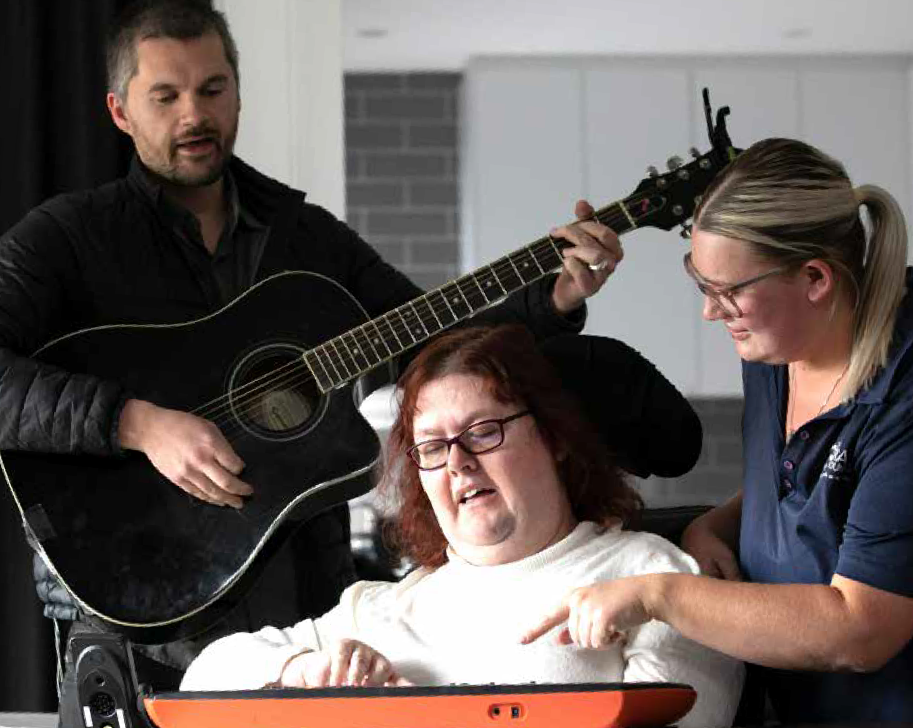
Many of Cram’s Participants are non-verbal and require assistance in every aspect of their lives. Although they deeply want to take part in activities, unless it is a tailored program to their abilities, they miss out. During the COVID pandemic, Cram workers identified a lot of isolation for our Participants – due to the complexity of their needs, they’re often excluded from mainstream disability activities and this was exacerbated during the peak of COVID. There was also a significant decrease in access to the arts and creative arts for people in general during COVID.
Figure 36: Image of Participant Jen and Music Therapy Teacher

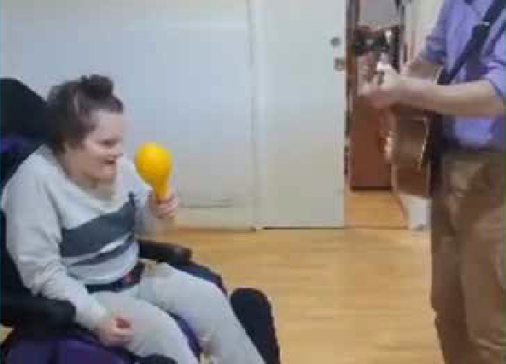
Figure 37: Image Participant Amber shaking maracas
Through this collaboration with WollCon, we can bring our Participants this program in their own environment, on their own terms, and cater to their abilities. Making it a truly inclusive program.

Since the beginning of the program, 16 Cram Participants have sung, played instruments, written songs and performed their way through weekly sessions with musical artists, Bertie McMahon and Harry Tregilgas. Guided by the Participants, the high level aims of the project have produced spine-tingling experiences for the Participants, staff and musical artists.

An example of the programs tailored approach can be demonstrated through the involvement of one of Cram’s Participants who has both intellectual and physical disabilities, who cannot communicate verbally, is deaf and visually impaired. Bertie was briefed by the participant’s care team and amended the program to suit his needs. Bertie now engages weekly playing along to middle eastern music with a tablah (drum). The tablah is placed on the side of the participant’s bed so he can feel the vibrations which elicits the reaction of smiling broadly, eyes and arm movements and immersion in the activity.
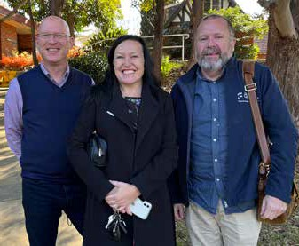

The program has also produced a ‘duo’ with two Participants, who are also housemates, attending the music facilities at WollCon weekly to spend time with Bertie. Part of their bespoke programming is song writing, which has seen them write and perfom songs called ‘Take
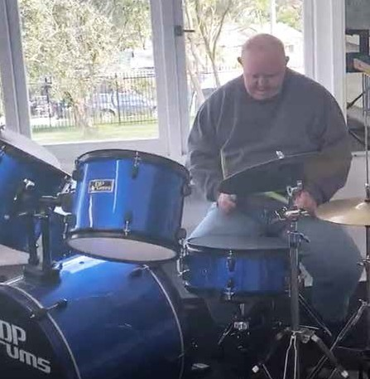
away’, about their love of take away food and ‘Haircuts’. They take their inspiration from the activities they enjoy in their everyday lives, with the musical artists guiding them in song writing and performance. Covering some classic artists like ABBA, making use of a drum kit, a guitar and a piano. The enjoyment and confidence the Participants get from taking part in this program is a key focus for WollCon, who aim to make their services and programs accessible to all people.
Figure 38: Participant Richard on the drums

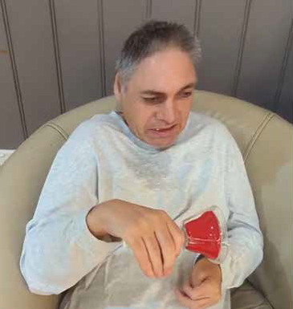
Figure 39: Participant Stephen in the Music Therapy Program
What Cram loved about the Create grant was that our partnership with WollCon would see the development of a truly different program, unlike others on offer. The program allowed the individual’s creativeness to just unfold – it is in the unfolding that we started to see the outputs from those taking part, and the Participants are helping to design this collaboration.
FINANCIAL REPORT
The financial year end 2022 – 2023 produced an operating surplus of $204,486 Total Income $20,587,131
- NDIA
- Participant fees
- Intern earnings, donations, insurance payments and other

Total Expenditure $20,349,971
- Employee expenses
- Operating expenses
- Depreciation and interest expenses

Total assets were $13,689,402 of which $7,044,217 were current assets, comprised primarily of cash reserves; $6,645,185 being non-current assets comprising of buildings, right of use assets, motor vehicles and furniture/equipment.
Total liabilities were $5,234,591 of which $3,187,752 were current. Net Assets $8,454,811
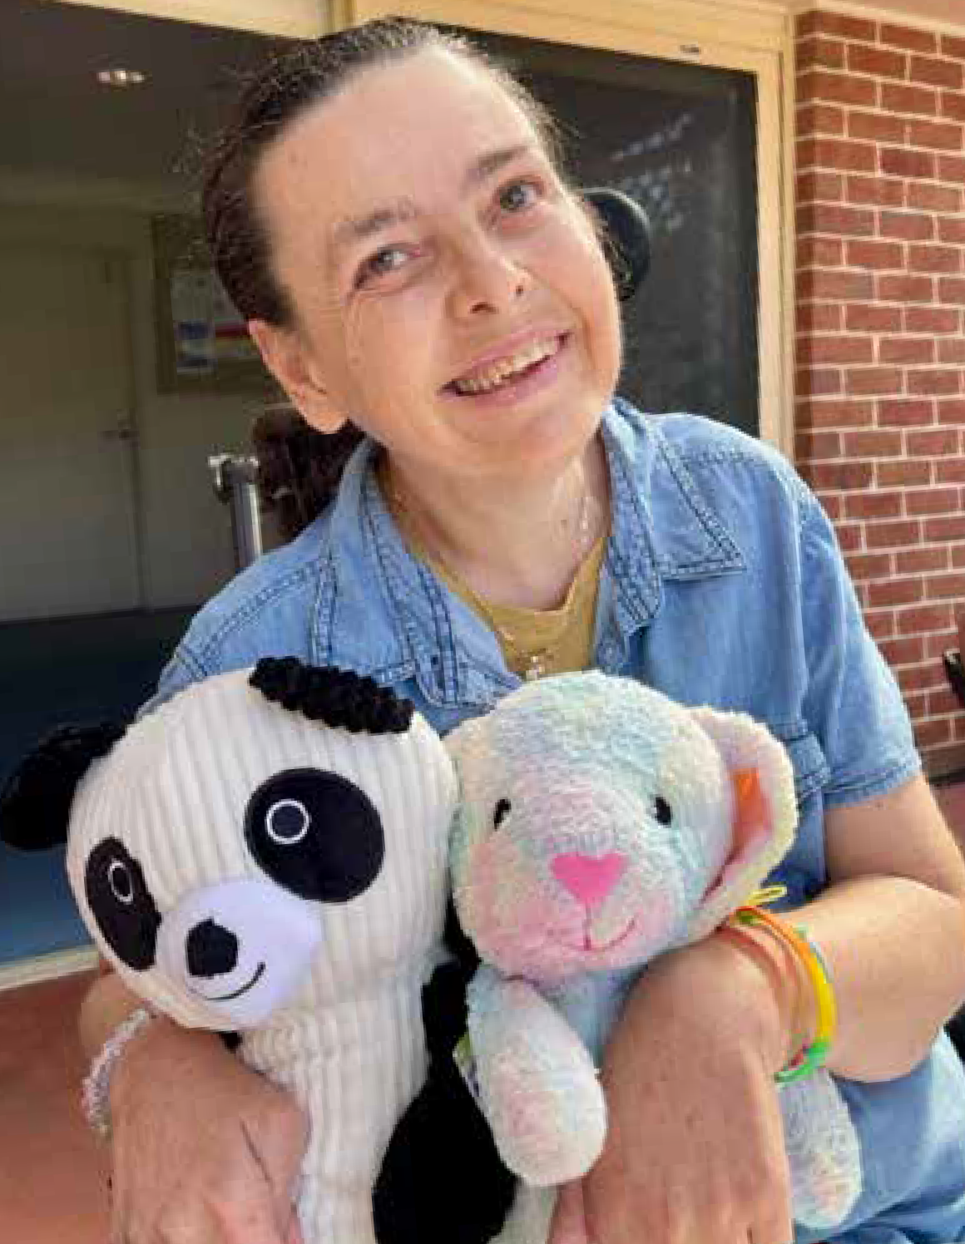
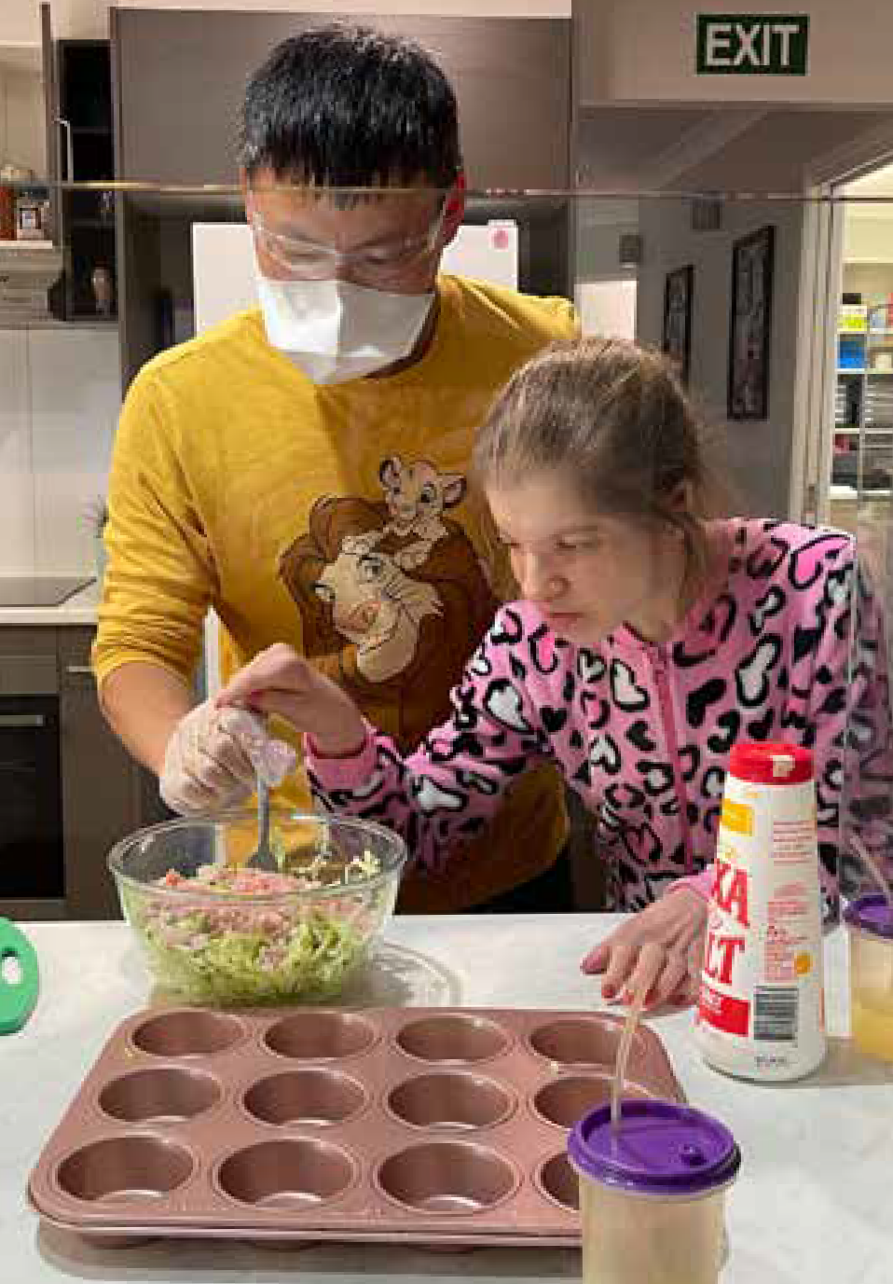
We also saw opportunities for the Participant’s families and loved ones to engage – sometimes seeing for the first time what interests the Participants. The final step for the Participants is a digital record of their time in the program. Footage and images they curate to go with the songs and music they have created.
Figure 40: Participant Vaness at the Teddy Bear's Picnic
Figure 41: Image Ash making cupcakes
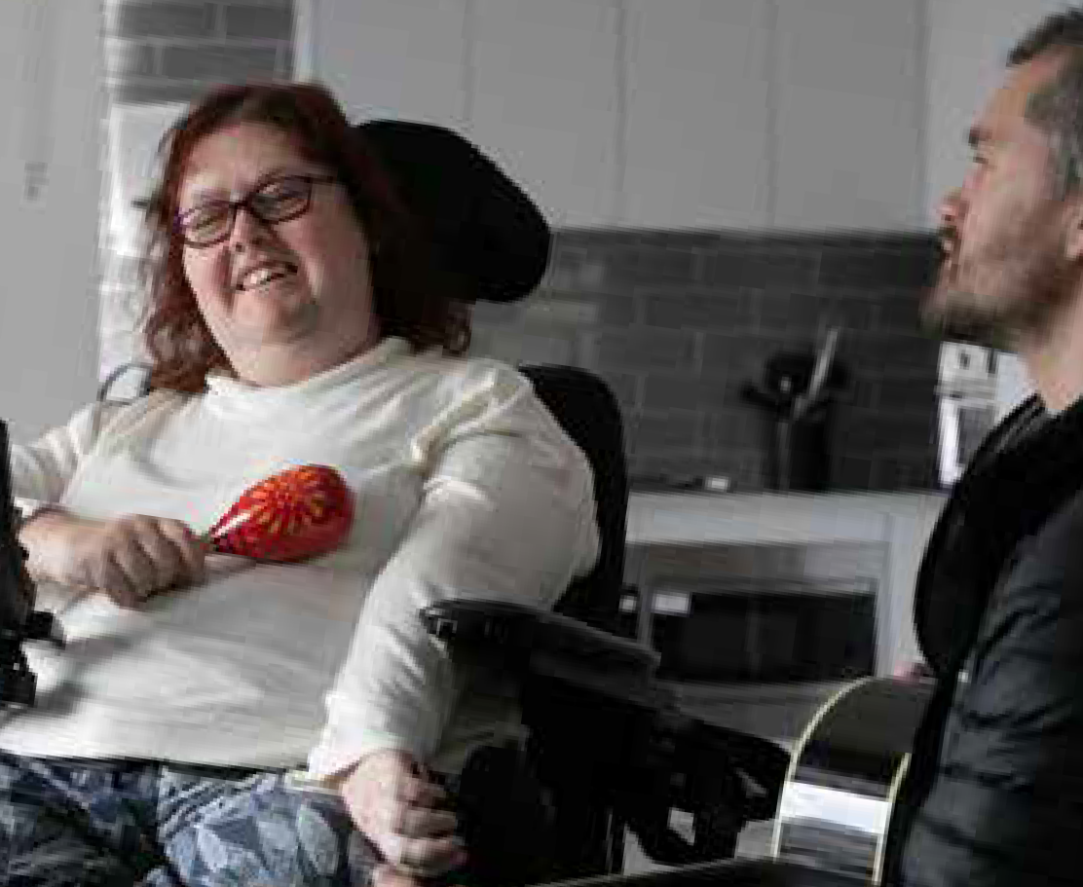
Figure 42: Participant Jen at the music therapy program
The beauty of this partnership is it completely breaks down preconceived ideas about what music and performance should look like. There is a deep and meaningful result for anyone who touches it. By taking an open and reflective approach we’ve ensured this program, executed like a pilot, can be developed into future opportunities so more people and creative mediums can benefit. Through the design and execution of this program, entirely from within The Cram Foundation and The Wollongong Conservatorium of Music, we have shown there is another way to enjoy music.

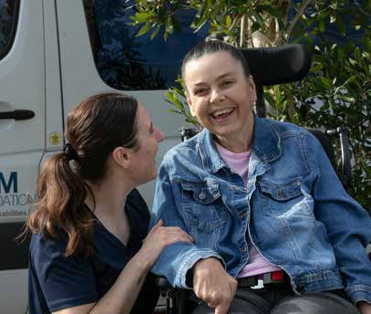
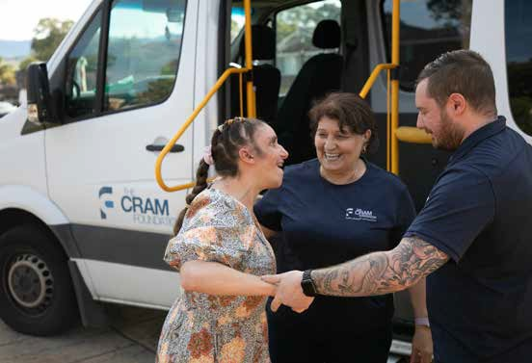
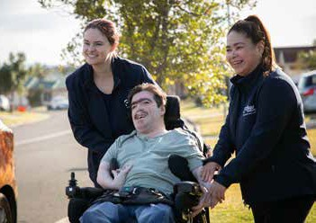
Table 2: Cram Advertisement - Home and Living Vacancies
The Cra Foundation

Supporting people with disabilities.
Home and Living Accommodation Vacancies
Choose a provider that has a proven history of genuine care and quality service delivery.

♦

Take the guesswork ♦
out of this major life ♦
decision.
♦

ABN - 45 001 327 519
28

